COMING SOON!!
The Customer Support & Literature Ordering Center is Transitioning to the *All New* Marketing Resource Center
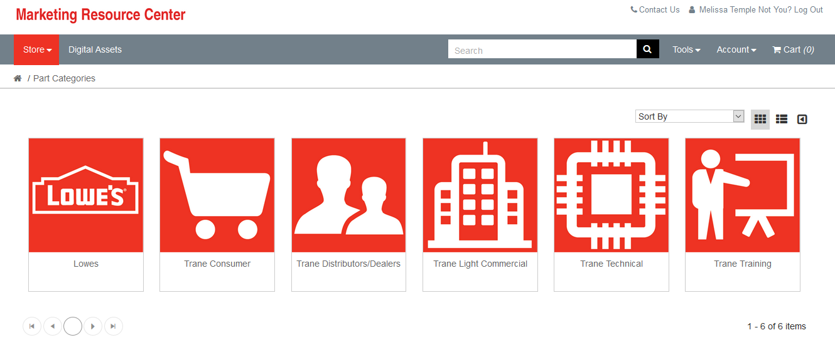
You’ll notice this new site has a new name. It’s also a brand new platform, still facilitated by Mira, formerly Pretty Incredible!.
Some key features and benefits of this new platform are as follows:
- More intuitive user experience
Optimized for mobile usage
- Intuitive re-ordering process
  - Simply click on the order you’d like to re-order, click the Re-order button (marked below with an orange circle) and the items will be automatically dropped into your cart.

  - Another way to re-order is through My Library – a completely new function of this platform. ‘My Library’ collects your personalized art as you re-order. So, if you know you want to re-order this business card, but you aren’t sure which order # it correlates with, no worries...simply order from ‘My Library’.

- Handy Favorite functionality
  - You now have the ability to mark Favorite i.e. publications you order time and time again, so you don’t have to search for them every time. Simple click the star (marked with a navy circle below) on one of your Favorite items and it will import into the ‘My Favorites’ tab under your account.

- Ordering in eaches vs. packs
  - On the old platform, if a publication was sold in packs of 25, you had to order 1, meaning you were ordering 1 pack of 25. It was very confusing if you were ordering 25 or 1 of something. On the new platform, if a publication is sold in packs of 25, you order how many you want, whether it’s 25 or 100, and the system will force you to stay with the pack quantity, if applicable.

- Zippy, caching search engine
  - In the below example, you can see ‘Consumer’ was input. It will pull all consumer literature. Then, ‘Furnace’ was input, and it narrowed down the search dramatically + instantly.

- More user-friendly, intuitive shopping cart
  - This shopping cart gives you all the information you need to proceed and make an informed decision.
  - The ‘Click for Discounts’ button (marked with a navy circle below) allows you to see how your total will change if you change your quantity from 499 to 500, in real-time.
  - If you’re placing an order for more than one personalized item, it can get a bit confusing which is why you have the ability to view/edit every proof before your continue checking out. Click on the eye icon (marked below with an orange circle) to view the proof, click the pencil icon (marked below with an orange circle) to edit the proof.

Stay tuned for more details!

