# Supporting K-12 Customers during the Pandemic

### Our job is to support customers and keep students, staff and the community comfortable while in their schools.

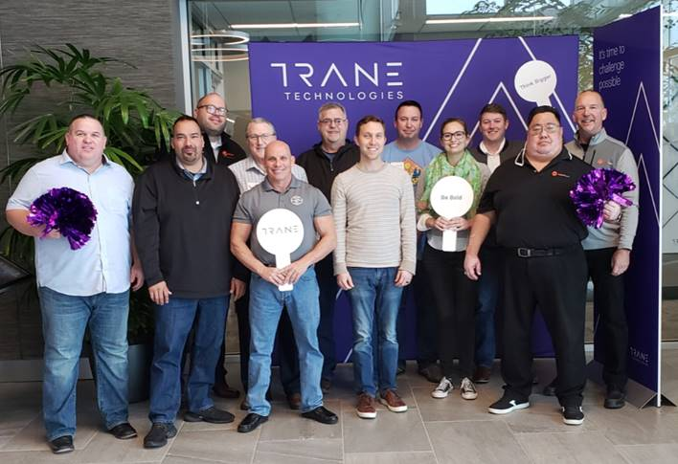

Before the COVID-19 (coronavirus) pandemic was announced, a core group of 10 account managers and one store leader, who all focus part of their business on K-12 education customers, met in Davidson, NC to:

* Present K-12 best practices
* Network & learn from each other
* Grow K-12 customers **transformationally** vs incrementally

After meeting, the whole team agreed that **account plans** are one of the **key pillars** to:

* Gaining **transformational growth**
* Being more **efficient** with their time
* **Consultative selling** with their customers
* Help with **proactive planning**

With that in mind, many AMs put helping schools during the pandemic as an **action item in their account plan**. Since they intentionally and strategically focused on helping schools this lead to a number of success stories and earned increased business (below)! Many **schools are closing nationwide** and will need to clean their HVAC systems before students can return. Now is the time to be there for your schools and provide the support they may need.

|  |  |  |
| --- | --- | --- |
| **Location** | **Situation** | **Result** |
| Dallas/Ft. Worth | *Proactive planning using an account plan:*  **Leo Sosa** is focusing on [RGF](https://www.rgf.com/hvac-marketing-materials/) and NuCalgon products for his intentional sales “phone” calls and customer emails. | * **20 RGF unit quote** after a combination of a K-12 marketing email on the flu and Leo follow-up * **4 different K-12 school leads** from a RGF and NuCalgon Evap-Fresh email |
| South Florida | *Proactive planning using an account plan:*  **Adam Uchin** and **Jennifer Gauthier** are focusing on IAQ and schools. | * Local university is testing out **NuCalgon Evap-Fresh** (CHM00707) and spray cleaner (CHM01083) and ordered **8 gallons of each**. * Miami-Dade School Board purchased some filters from us and are looking to replace **all their filters** at their schools since a competitor provided a poor customer experience. They are quoting 50 different filters within a few days. |
| South Texas | *Proactive planning using an account plan:*  **Brady Bishop** is focusing on IAQ for his intentional schools calls | * Sold **15 REME HALOs** and 15 more to be installed in April to a local university * Same university has an open quote for **30** [**TUV-MINI-LEDs**](https://www.freshaireuv.com/residential/mini-uv-led) for their dorm mini-splits |
| Chicago | *Proactive planning using an account plan:*  **Matthew Polowy** & the **Aurora store** reached out to Valley View School District and they are now using NuCalgon Evap-Fresh (CHM00707) products | * Valley View Schools purchased **65 gallons.** * Reached out to more schools 🡪 **secured more orders** |

# **Action Needed:**

1. Create an **[Account Plan](https://home.ingerrand.com/:x:/r/sites/hpp/marketing/lpad/Documents/K-12%20education%20segment/BLANK%20TEMPLATE_Account%20Planner%202020.xlsx?d=w3d8621b6e5dc4683935cb239390dbd45&csf=1)** for your K-12 accounts(blank template attached)
   1. **Pro tip**: K-12 assigned accounts **with** an account plan are **+10%** YoY vs K-12 assigned accounts with **no** account plan are **-1%** YoY
   2. **Analyze** your K-12 customers in the [**K-12 Feb 2020 mix report**](https://home.ingerrand.com/:x:/r/sites/hpp/marketing/lpad/Documents/K-12%20education%20segment/Data/Mix%20report/Mixreport%20V4_K-12_022020.xlsx?d=wee1d1ea8528146bf81726e2654fc956d&csf=1)
2. **Read** the ***new*** [**K-12 one-page playbook**](https://home.ingerrand.com/:b:/r/sites/hpp/marketing/lpad/Documents/K-12%20education%20segment/K-12%20one%20page%20playbook_012020.pdf?csf=1) to understand a high-level overview of K-12 customers
3. Target at least 3 schools with your CSO counterpart
   1. **Attend and participate** in **local CSO sales meetings** to build stronger relationships

# **Questions and Answers:**

|  |  |
| --- | --- |
| **Where can I find more information on K-12 customers?** | The [K-12 education segment playbook](https://home.ingerrand.com/:b:/r/sites/hpp/marketing/lpad/Documents/K-12%20education%20segment/K-12%20playbook_012020_v5.pdf?csf=1) is the first step in your journey. It identifies the tools/programs, key decision makers and questions to ask to be successful with this vertical market. |
| **How do I sign into Omnia Partners?** | [https://omniaconnect.omniapartners.com/](https://urldefense.proofpoint.com/v2/url?u=https-3A__omniaconnect.omniapartners.com_&d=DwMFAw&c=RqOSY-j6o2m72bl3g1aM9A&r=iUv0xiayB1q601rpe5UdWF-Fr89euE_bMAit9YSfHQk&m=jWB4_LOclyfxrHFdRbMDYHlMLbjWvbXayC-xWMmT9H8&s=KQMHdgeRsIfrIC1WlHl5hqoSx9OaNARAun_HREGn3NA&e=)  User name: TraneCOOP@irco.com  Password: Trane001 |
| **Is there training on Omnia Partners available?** | Omnia Partners training: 30 min training, also broken down into bite size pieces 🡪 [link](https://home.ingerrand.com/sites/hpp/marketing/lpad/Pages/default.aspx?RootFolder=%2Fsites%2Fhpp%2Fmarketing%2Flpad%2FDocuments%2FK%2D12%20education%20segment%2FOmnia%20Partners%20%28formerly%20US%20Communities%29&FolderCTID=0x01200098817C00E1919043BF7904E62FA5AD73&View=%7BD09380E4%2D5D09%2D410D%2D9426%2D171263E5757D%7D) |
| **How do I use Govspend?** | Reach out to [christoph.vonimhof@irco.com](mailto:christoph.vonimhof@irco.com) to get signed up for a personalized territory “playlist” |
| **I have more questions on K-12 customers?** | Contact [christoph.vonimhof@irco.com](mailto:christoph.vonimhof@irco.com) |