

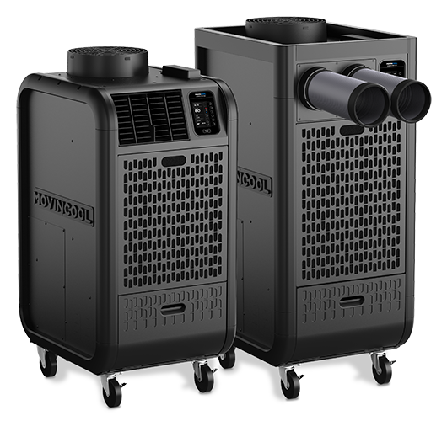

**Purpose & Summary**

MovinCool New units are now available!

Please see below for details on

1. Upcoming Webinar schedule hosted by MovinCool
2. New model numbers and part number nomenclatures
3. Marketing plan summary
4. New product features

**Upcoming Webinar schedule**

* MovinCool will be hosting 3 Webinars
  + March 25: WebEx new product training 2:00 pm EDT
  + April 3: WebEx new product training 3:45 pm EDT
  + April 8: WebEx new product training 11:30AM EDT
* Look for this communication coming from the BOS Team
* Webinar will focus on new product training led by our MovinCool National Sales Rep, Brad DeHore

**New model numbers and part number nomenclatures**

* We will be using MovinCool Model number going forward rather than our mnemonic
  + UNTXXXXX will be replaced with CLIMATEPROXXX
* We will also be changing the component parts and accessories from our mnemonic to MovinCool part numbers
* We will be using MovinCool’s website to ID replacement part and will not parts list the new models in WebCats. If you enter the new model number in Webcats you will see instructions on how to ID parts on MovinCool’s website
* If you have any existing inventory of MovinCool parts or accessories, you will need to adjust the old part out of inventory and adjust in the new part, using the item number change adjustment code for the inventory adjustment and adjust both the old and the new in the same adjustment.
  + I’ve included the current inventory position as of 3/11 and the old part to new part.

**Marketing and training plan summary**

* Internal webinars detailed above
* Launch Pad
  + Catalog, Flyers, Accessory list,
* External email blast to Supply customer going out April 1st
* Schedule your open house with our MovinCool Sales Rep, Brad Dehore (contact info below)
* We have Literature available through Print on Demand

**New product Features**

These new units will have a brand new look and some new features to include:

* Modern Black Appearance: Color will blend nicely in server room, office, or manufacturing area
* Bumpers added on sides to prevent damage to panels and for moving.
* New, dual position nozzle design with quick change out on industrial models.
* Power cord holder pocket to protect cord and plug form damage during storage.
* Quick change from louvres to Nozzles on office style units.
* Improved mobility as a result of larger casters.
* Improved packaging design with integrated guide rail on pallet for easier pallet unload.
* Ergonomically designed drain tank. Easier transport with one hand.
* Serviceability: Easy access to display panel with just 3 screws.
* New color display control panel with user friendly instructions for clearing codes.
* Up to 24,000 Btu/h can be double stacked resulting in less warehouse space for storage.
* Flange built in all models. No flanges to stock or for end user to purchase.
* Remote monitoring features including web portal standard (requires monthly subscription)

**Action**

1. Attend one of the upcoming Webinars
2. Order the new brochures and catalogs for your store
   1. Determine what flyers and catalogs found on the Launch Pad you want an order Literature [Here](https://www.reqdirectplus.com/tranetechnologies/UI/Login_tranetechnologies.aspx?db_profile=tranetechnologies)
3. Set up a Display unit in your store.
4. Review your forecast for both Units and Accessories and work with your Retail Planner to make sure you have the right inventory in place.
5. Review you Rental Strategy with your local leadership.
6. Talk to your customers about these new products and all the great new features!

**Additional Resources / Contact:**

For any additional information contact Product Management (Ryan Goodwin or Rita Towner).

<https://movincool.com/portable-air-conditioners/>

[Launch Pad](https://home.ingerrand.com/sites/hpp/marketing/lpad/Pages/default.aspx?RootFolder=%2Fsites%2Fhpp%2Fmarketing%2Flpad%2FDocuments%2FMovinCool%20Portable%20Air%20Conditioners&FolderCTID=0x01200098817C00E1919043BF7904E62FA5AD73&View=%7BD09380E4%2D5D09%2D410D%2D9426%2D171263E5757D%7D) We are still updating this so check back often.

MovinCool Rep:

Brad DeHore, Sales Manager  
559-909-4141

[BRAD_DEHORE@densodrive.com](mailto:BRAD_DEHORE@densodrive.com)

